Moblin and MAEMO
I've found device that looks like as maemo (Nokia810). Source: http://www.linuxcenter.ru/moblin
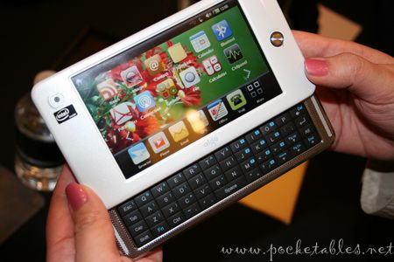 | 

