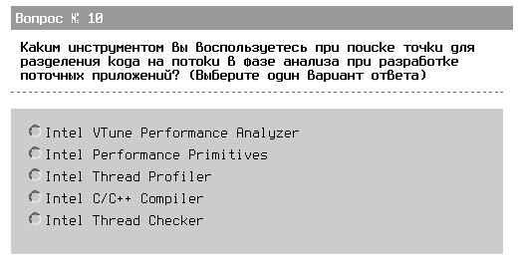
dumb:
- Thread profiler входит в состав VTune: http://www.intel.com/cd/software/products/asmo-na/eng/286749.htm , http://www.intel.com/cd/software/products/asmo-na/eng/219898.htm
- не 2: Intel® Integrated Performance Primitives (Intel® IPP) is an extensive library of multi-core-ready, highly optimized software functions for multimedia and data processing applications. http://www.intel.com/cd/software/products/asmo-na/eng/302910.htm
- не 4, очевидно (:
- похоже, не 5: http://www.intel.com/cd/software/products/asmo-na/eng/286406.htm

