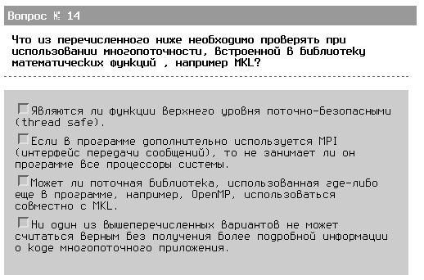
kel: http://www.intel.com/support/performancetools/libraries/mkl/sb/cs-017177.htm - Intel MKL is threaded in a number of places: LAPACK (*GETRF, *POTRF, *GBTRF routines), Level 3 BLAS, DFTs, and FFTs. Intel MKL uses OpenMP* threading software. There are situations in which conflicts can exist that make the use of threads in Intel MKL problematic. We list them here with recommendations for dealing with these. First, a brief discussion of why the problem exists is appropriate. То есть 3 - видимо да, что касается 2 - думаю сильно зависит от кода приложения + может только снизить производительность, но не привести к ошибкам.

